**Welcome to St. Himark!**

St. Himark is a vibrant community of 246,839 people located in the Oceanus Sea. Home to the world-renowned St. Himark Museum, beautiful beaches, and the Wilson Forest Nature Preserve, St. Himark is one of the region’s best places to raise children.

While St. Himark has everything a family needs, it’s also easy to stay connected to the outside world thanks to the five bridges and one highway that connect St. Himark to the mainland:

MAGRITTE BRIDGE

FRIDAY BRIDGE

JADE BRIDGE

12TH OF JULY BRIDGE

HIMARK BRIDGE

WILSON FOREST HIGHWAY

**Government**

St. Himark is governed by Mayor Jordan and the city council, all of whom are elected to represent the entire city. A city manager is responsible for the executive leadership of the city staff, as well as implementing council policies, developing programs and budgets to respond to council goals, and ensuring that citizens receive effective and efficient city services. The city manager also serves as the city treasurer.

**Utilities**

WATER and SEWER

The St. Himark Department of Water and Sewer manages the city water supply infrastructure and the sanitary sewer system. Call our Emergency Service department if you need emergency service from the Water Department, including having your water shut off because of a broken pipe, observing a broken fire hydrant, or if your water service is off and you are not sure why.

Current Water and Sewer Projects: Please slow down and drive safely in construction zones

* Old Town – old water supply lines are being replaced throughout the neighborhood. We apologize for any inconvenience for this very necessary repair work.
* East Parton – a broken water main is currently being repaired at the intersection of Blair and Quealy.
* West Parton – routine maintenance on the sewer lines is ongoing.

ROADWAYS, STREET, AND BRIDGE MAINTENANCE

St. Himark’s Street Operations Division maintains public streets and traffic signals and operates the city’s traffic management system.

Current Road Construction Projects: Please slow down and drive safely in construction zones

* Wilson Highway – shoulder repair resulting in occasional traffic delays.
* Broadview, Scenic Vista, and Southton neighborhoods – resurfacing of residential streets resulting in minimal delays to traffic.
* Downtown neighborhood – resurfacing of collector roads, traffic signal repairs. Delays expected.
* Chapparal and Cheddarford neighborhoods – resurfacing of collector roads. Expect delays.
* Friday Bridge – guard rail repair. Expect some delays.
* Magritte and Jade Bridges – repair of bridge decking. Lanes are restricted. Expect delays.

GAS

Thesaurus Natural Gas Company provides natural gas to the residents of St. Himark. If you smell gas, leave the area immediately and call our emergency service number. Please call us two days prior to doing any digging.

Current Projects: None. All systems operational.

GARBAGE

Residential and commercial waste disposal is provided by Himark Disposal Company. Residential collection is weekly. Commercial collection is weekly, but can be provided more frequently.

POWER

The St. Himark Power Department is responsible for providing electrical power to the city. Currently the city’s power is primarily supplied by the Always Safe Nuclear Power Plant, with solar and wind providing 12% and 16% of the total supply, respectively. Please call us two days prior to doing any digging.

Current Projects:

* Old Town – we are working to modernize the electrical distribution system. Expect power outages lasting 30-60 minutes throughout the week.
* Southwest – repairs to the substation that supplies Southwest is causing intermittent power outages.

Always Safe Nuclear Power Plant

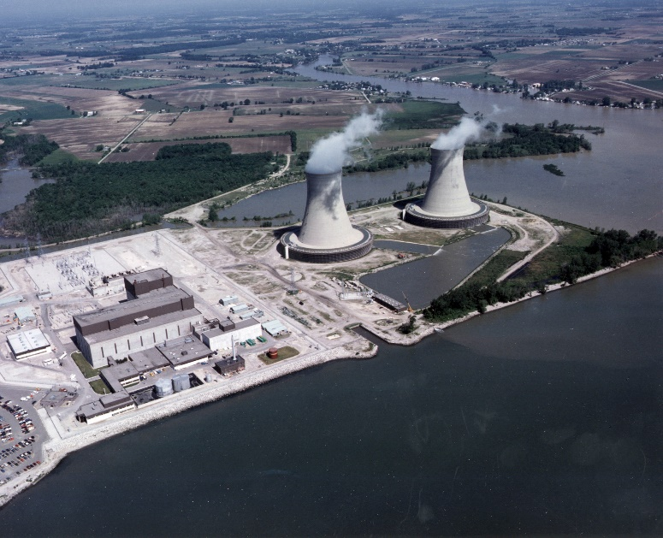

The Always Safe nuclear power plant provides 72% of St. Himark’s electricity and provides jobs for 700 highly skilled professionals. Always Safe is community minded and actively involved with a number of local service organizations including the St. Himark Animal Shelter, the City Food Bank, and the Himark Public Library system. Additionally, employees of Always Safe are encouraged to join in after-school science and math mentoring programs and to donate blood and plasma at area hospitals.

Built in 1965, Always Safe is a 200 Megawatts electric (MWe) pressurized water reactor (PWR). PWRs use ordinary water as both coolant and moderator. The design is distinguished by having a primary cooling circuit which flows through the core of the reactor under very high pressure, and a secondary circuit in which steam is generated to drive the turbine to generate electricity.

**Neighborhoods**

St. Himark is subdivided into nineteen neighborhoods each with a unique lifestyle ensuring there is a place for everyone in St. Himark!

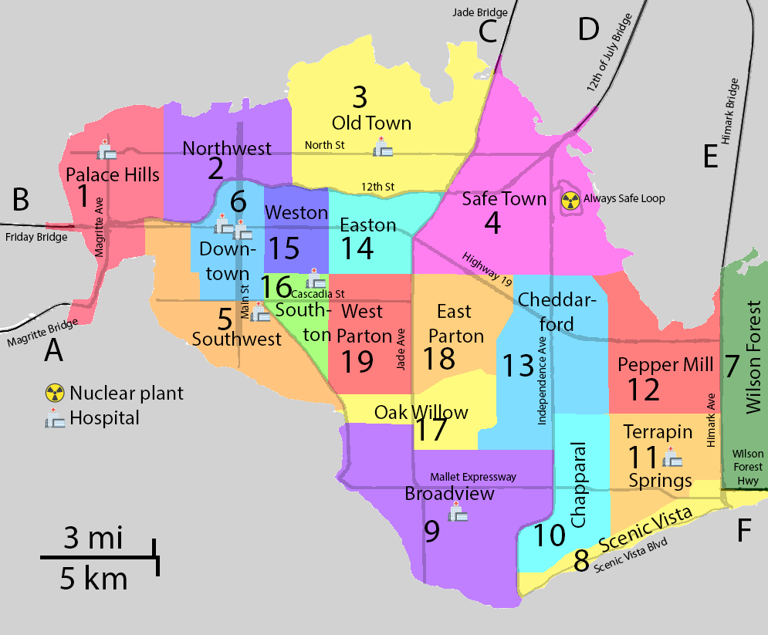

1. PALACE HILLS is home to luxury condominiums and gated housing communities with private beaches. This community is known for water views, great restaurants, and waterfront parks.
2. NORTHWEST is a growing neighborhood of upscale condominiums, modern apartment buildings, and townhouses known for their water views, good schools, and short commute to downtown St. Himark.
3. OLD TOWN is the historic center of our city and the structures here are renowned for their decorative brickwork. Affordable housing is available in apartments and older single-family homes that are close to some of the city’s best restaurants.
4. SAFE TOWN is a neighborhood of older single-family homes providing an easy commute to the Always Safe nuclear power plant and other local industry. Residents can live close enough to work to be able to go home for lunch!
5. SOUTHWEST’s mixture of light industry, single-family homes and garden apartments, and theaters provide for an environment where work, home, and play are within walking distance of each other.
6. DOWNTOWN is the heart of the city where fast-paced business day-life and city nightlife converge. Housing is an eclectic mix of luxury lofts and modest apartments.
7. WILSON FOREST is a developing area of new single-family homes in a beautiful, tranquil, wooded area on the edge of the Wilson Forest Nature Preserve. Life in Wilson Forest feels like you're in the country with a reasonable commute to everything the city has to offer.
8. SCENIC VISTA has large, custom-built single-family homes to secure, gated communities, trendy apartments, and exclusive condominiums that have spectacular views from the hillside overlooking the ocean. Many of the city’s elite and powerful call Scenic Vista home.
9. BROADVIEW’s older single-family homes known for their architectural styles and masonry construction are mixed with city parks, providing a great place to raise a family. Located off the Mallet Expressway for easy commuting into the heart of the city.
10. CHAPPARAL’s rural lifestyle and rustic 18th and 19th century farmhouses accommodate those who want the acreage to raise livestock and still live close to the city.
11. TERRAPIN SPRINGS mixes farm houses with newer, custom homes with lots of acreage. Terrapin Spring’s High School boasts the best farm training program in the country!
12. PEPPER MILL’s low-density housing, great restaurants and shopping along the water attracts tourists and locals alike.
13. CHEDDARFORD’s quiet residential areas and slow-paced lifestyle are the perfect place for raising a family.
14. EASTON is renowned for excellent schools and quaint single-family brick homes with manicured lawns. If your life revolves around your children, you will love living in the Easton neighborhood.
15. WESTON is a great place to live if you work in Downtown. Cozy condos and apartment, and lofts above businesses attract college graduates and single professionals looking for an area with all the benefits of city and suburban life.
16. SOUTHTON is a quiet neighborhood of older homes and modern garden-style apartment buildings.
17. OAK WILLOW is close to work, shopping and nightlife for educated couples and young single professionals.
18. EAST PARTON is known for its masonry facades, strong community sports programs and short commute.
19. WEST PARTON, located in the heart of the city, is home for families looking for a short commute to work and play call. The St. Himark Museum is conveniently located in West Parton.

Y*INT NEIGHBORHOOD MESSAGING APP

St. Himark has deployed a free, neighborhood-based messaging app for its citizens designed to help build our sense of community in the information age. Simply sign up with your user name and home neighborhood and you can chat on your computer or phone.

**Education**

St. Himark is home to the highest rated schools and university in the region. There are a variety of education choices for families, young adults, and professionals seeking continued education opportunities.

PUBLIC SCHOOLS

There are several public schools among the five school divisions that serve the educational needs of our children:

Old Town Unified School Division

Broadview Unified School Division

Terrapin Springs Unified School Division

Easton Unified School Division

Parton Unified School Division

ST. HIMARK UNIVERSITY

St. Himark is proud to be the home of the world-class St. Himark University, a centuries-old institute with a mission to benefit society through science, engineering and conservation.

Of particular note is the famed Alderwood Data Sciences Institute, founded in 2006by Professor Mark Boynton. The Institute challenges the most pressing problems in today’s highly interconnected world. Professor Boynton pioneered the process of creating meaningful synthetic data to drive the development of innovative visual analytic tools. Professor Boynton’s contributions to the science of visual analytics are foundational and his methods provided the basis for progressive research and development all over the world. Upon his retirement in 2018 St. Himark city officials celebrated his accomplishments, contributions to education, and his commitment to the data science community by naming him a First Citizen of St. Himark, an honor bestowed upon those people who have made a lasting contribution to the city. A statue of Professor Boynton was dedicated on January 20 at the entrance to the Alderwood Data Sciences Lecture Hall.

St. Himark University is also home to the Whiting Puffin Conservancy, a foundation dedicated to the preservation and protection of the seabird *alca pennsylvannus.*

**Healthcare**

St. Himark has an exceptional network of eight hospitals. This top-quality medical service includes many leading specialties staffed by doctors who have received world recognition.

HIMARK GENERAL in the Palace Hills area of town is known for its advanced medical surgical care. The Cardiology Center provides the full spectrum of state-of-the-art care for heart patients.

OLD TOWN HOSPITAL in the historic Old Town district is known for its expertise in diabetes and endocrinology, digestive health, oncology, and orthopedics.

TRAUMA HOSPITAL in Downtown Himark is the only Level 1 Trauma Center in the area, just one of three burn centers in the region, and has the largest Neuroscience Intensive Care Unit in the city. Trauma Hospital also serves as the primary teaching affiliate of the St. Himark University School of Medicine.

CHILDREN HOSPITAL in Downtown Himark is a dedicated pediatric center providing world-class care to the children of St. Himark and the surrounding region.

COMMUNITY HOSPITAL in the Broadview neighborhood offers a full spectrum of medical care tailored specifically to the patient needs.

GOLDCARE HOSPITAL in Terrapin Springs is a full-service, non-profit community hospital, offering comprehensive medical, surgical and therapeutic services.

EAGLEPEAK HOSPITAL in Southton is known for its critical care, neurology, gastrointestinal, and orthopedic care.

**Emergency Services**

St. Himark’s City Emergency Management team is here to keep you safe. Our network of 34 fire stations are staffed by highly-skilled emergency service personnel and equipped with state-of-the-art firefighting and rescue equipment. Our state-of-the-art Emergency Operations Center is staffed by highly trained individuals who will assist with the coordination of emergency services in the event of an emergency situation.

RUMBLE

Developed in partnership with the University of St. Himark and the City Emergency Management agency, Rumble App crowd sources damage reporting. When a disaster strikes, seconds count and first responders need assistance with determining the extent of damage. Knowing what has happened informs decisions about where to send resources. Anyone can download the app and join your neighborhood team. When the disaster strikes, following the simple instructions to report damage that you see.

RADIATION MONITORING

City Emergency Management has deployed nine advanced radiation monitors, one at the entrance to the Always Safe nuclear power plant and eight dispersed around the city. These detectors provide near-real-time monitoring in the unlikely event of a radiological emergency.

*Background radiation is present on Earth at all times. The majority of background radiation occurs naturally from minerals and a small fraction comes from man-made elements. Naturally occurring radioactive minerals in the ground, soil, and water produce background radiation. The human body even contains some of these naturally-occurring radioactive minerals. There can be large variances in natural background radiation levels from place to place, as well as changes in the same location over time. Radioactive materials used in industry and even in some consumer products like building materials are also a source of small amounts of background radiation.*

**Himark Science Society**

The Himark Science Society (HSS) is a free-to-all public organization dedicated to bringing science to our community. Founded by Mark Boynton, HSS welcomes all who have a passion for science, including currently employed and retired scientists and engineers, hobbyists, and the curious. The current chairman of HSS is Marie Sklodowska. The next scheduled meeting of HSS is on April 6. All are welcome to come and hear Dr. Sklodowska speak on “Radiation and Our Environment”.